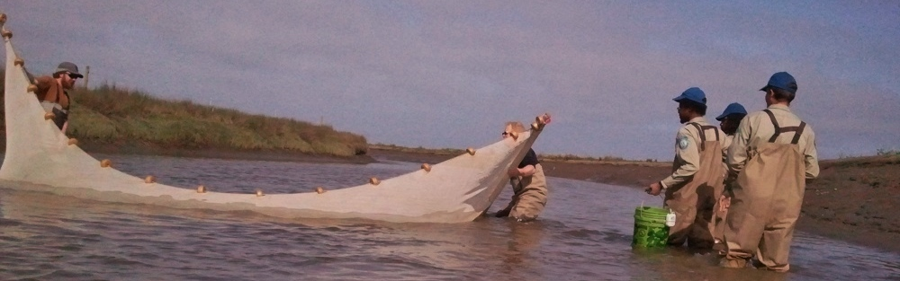
Fish Surveys in the Restored Salt River Estuary
Phase 1 (Riverside Ranch)
March 2014
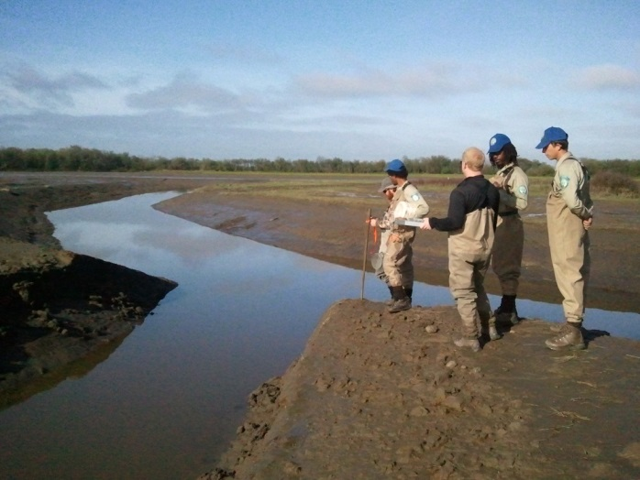
It’s been six months since the completion of active construction on Phase 1 of the Salt River Ecosystem Restoration Project. In October 2013, 2.5 miles of the river channel was deepened 12’ from an average depth of 8’, and widened 83’ from an average width of 11’. Over three miles of internal slough networks were excavated across 330 acres of a former organic dairy ranch. On October 28th, 2013, the newly constructed restoration site was opened to receive water from the Eel River and the Pacific Ocean for the first time in over 100 years.
Fish Crew deploying fish traps in the southern slough network
This March (2014) a fisheries crew consisting of AmeriCorps and California Conservation members was led by Allan Renger, CDFW District Fish Biologist, to sample 10 sites over 4 days across the restoration area during low tides. Juvenile smelt were seined in the Salt River, though it is expected to have a multitude of marine fish utilizing the area as the months progress. The slough network held some very happy surprises. Over 30 juvenile Federally Listed Endangered Coho Salmon (Oncorhynchus kisutch) were captured at sites near installed wood debris structures and at terminal branches of the slough network. At several terminal branches of the slough networks, specific back water habitat was created for another Federally Listed Endangered fish, the Tidewater Goby (Eucyclogobius newberryi). These fish are 3 to 4 inches long and are “not the most athletic fish” according to Allan Renger. Therefore, from over 3 miles from the nearest Tidewater Goby habitat, it was astonishing to find three gobies in their newly designated habitat!
Fisheries Crew Sampling the lower Southern Slough network
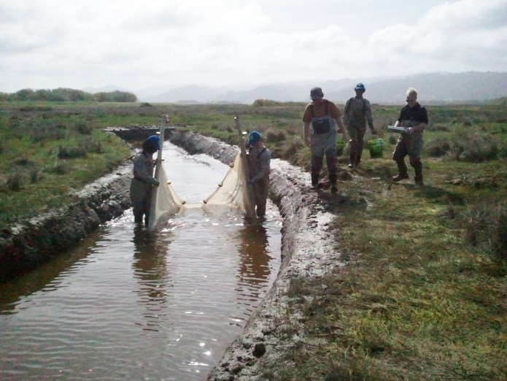
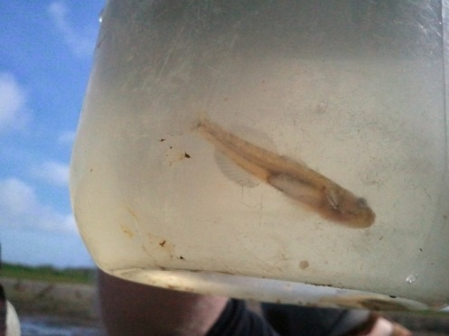
Fish surveys will continue each month until July. Currently CDFW is the lead during the surveys. As the summer months begin, a professor of fisheries biologist from Humboldt State University will be leading the sampling. Multiple partners are also interested to assist in the effort, such as, the National Marine Fisheries Service, HT Harvey, the Wiyot Tribe, and Humboldt State University students.
Fish Crew seining tidewater goby back water habitat
Seining the Salt River
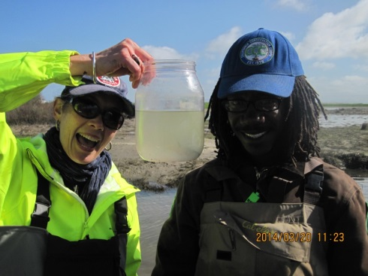
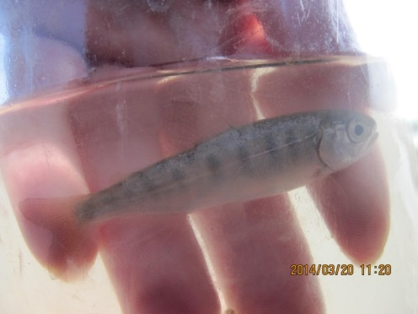
Juvenile Coho – photograph courtesy of CDFW
RCD staff and CCC member holding a juvenile Coho in a viewing chamber – photograph courtesy of CDFW

Tidewater goby in viewing chamber

