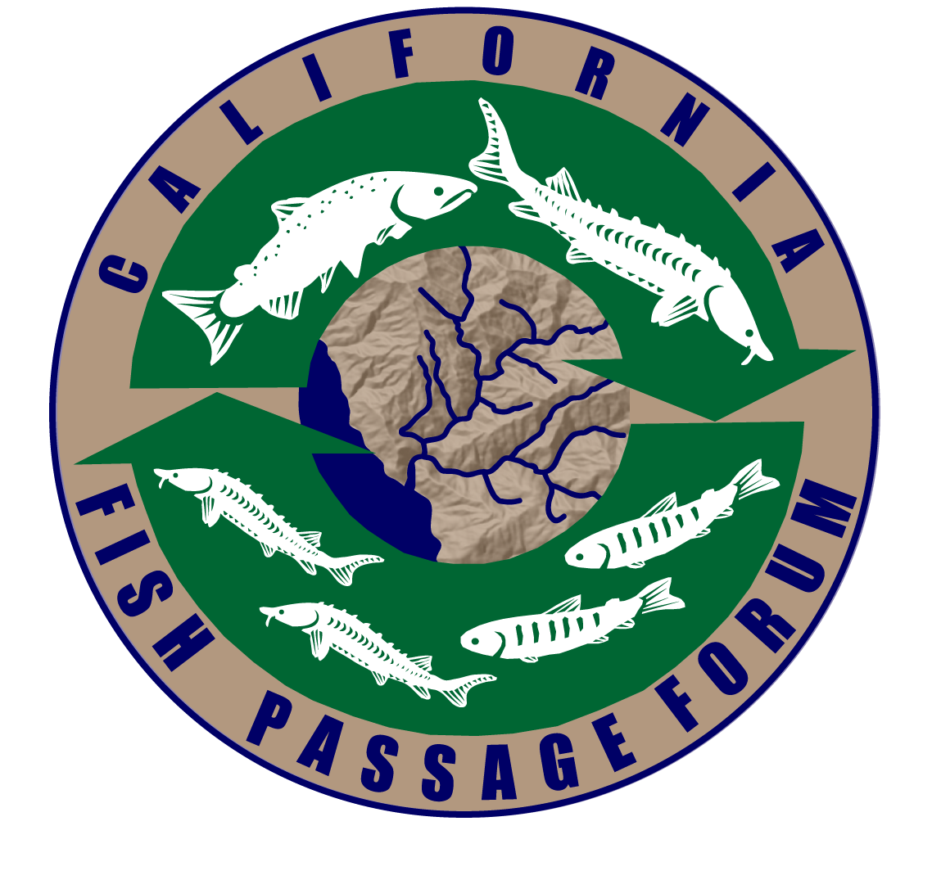

Meeting Agenda – California Fish Passage Forum
Date and Time: | August 8, 2018; 1pm–5pm Field Trip (No GoToMeeting)  August 9, 2018: 8am–4pm; Meeting (GoToMeeting information below)
Location: | NMFS; 777 Sonoma Avenue, Santa Rosa, CA
To participate in the meeting remotely: | Please join my meeting from your computer, tablet or smartphone.  https://global.gotomeeting.com/join/664513757  You can also dial in using your phone.  United States: +1 (224) 501-3412  Access Code: 664-513-757
AUGUST 8 |  |  | OUTCOMES
1:00pm–5PM |  | Field trip  Meet at Sonoma County Water Agency, 404 Aviation Blvd, Santa Rosa at 1pm to carpool. First stop is the large fishway and viewing gallery at Mirabel on the Russian River. Second stop is the summer dam and river grade control in Healdsburg: https://youtu.be/f4Kzd377XyQ | INFORMATION
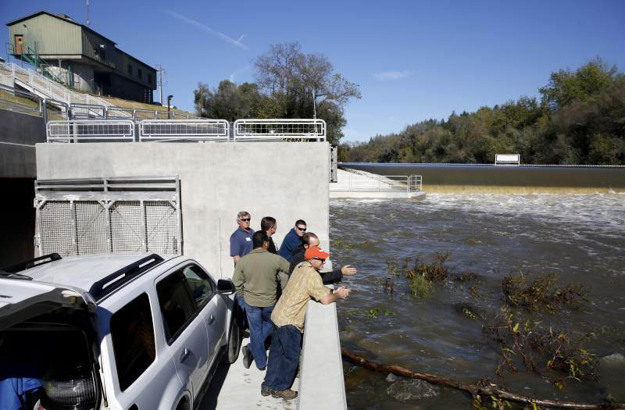
Fishway and viewing gallery at Mirabel on the Russian River.
aUGUST 9 |  | OUTCOMES
8:00AM – 8:30AM | Welcome and Introductions  Welcome, introductions, and review of agenda  Debrief and discussion post-field trip
8:30AM–10:00AM | Forum Administration  - Trout Unlimited Welcome, Other Committee Membership Updates (10 minutes)  - Forum committee work plans – Each committee will provide updates on their work plans and accomplishments to date, including challenges in achieving work plan items (30 minutes)  - Forum budget – Members will review the 2018 Forum budget (10 minutes)  - 2018 Project Status Update—Members will discuss the current status of all Forum projects, including new 2018 projects. (20 minutes)  - Harvey Diversion Project (Sandy)  - Forum Coordination—Key next steps (15 minutes)  - NFHP Funding News—(5 minutes)  - Fall Funding Announcement Timeline and Tasks (5 minutes) | INFORMATION and DECISION
10:00AM–10:30AM | BREAK
10:30AM–11:00AM | Because Bluelines Aren’t Enough; Turning Brownfields Into Green Floodplains  NOAA Santa Rosa, Endangered Habitats Conservancy, County of Santa Rosa, Lehigh Hanson, and the Coastal Conservancy are working on the proposed restoration of the Hanson Windsor Ponds area to historic floodplain habitat currently disconnected by levees. The goal of the project is to re-establish a stable, seasonal river-floodplain connection to restore essential ecological processes and functions to sustain off-channel aquatic, wetland, riparian, and upland habitats critical for the recovery of fish and wildlife (Brian Cluer, NMFS) | INFORMATION
11:00AM–11:15AM | Draft Form to Incorporate Lamprey Passage Considerations into the Passage Assessment Database  A draft form has been developed that integrates lamprey assessment form fields into the Passage Assessment Database to create a comprehensive fish passage assessment form (D. Goodman, USFWS) | DECISION
11:15AM–11:45AM | I-5 Trabuco Fish Passage Project in Orange County  The Alternatives Analysis report: Feasibility study with four alternatives with preliminary plans, will be presented for the I-5 Trabuco Fish Passage Project in Orange County (S. Jacobsen, Caltrout)
11:45AM–12:15PM | Results of the Juvenile Fish Jump Experiment at Warm Springs  The results of the Forum=sponsored juvenile fish jump experiment at Warm Springs coho captive broodstock facility will be shared, and potential steps to incorporate the results into the development of future guidelines will be discussed (R. Wantuck, NFMS)
12:15AM–1:15PM | LUNCH
1:15PM–3:00PM | FishPASS  Members will discuss the current status of FishPASS and key next steps:  - Presentation of the final comps by Ecotrust (Jocelyn Tutak, Ecotrust)  - Discussion of FishPASS input data (D. Goodman)  - Discussion of how to bring the FishPASS tool into decision-making processes (All)
3:00PM – 3:15PM | Wrap-up, Share Action Items | INFORMATION
3:15PM | ADJOURN

